1. What Is a Blazor Web App?
A Blazor Web App is a single project that can run:
- As Blazor Server
- As Blazor WebAssembly
- Or Auto mode (initial Server render, then WebAssembly)
This replaces the older separate Server and WASM templates.
2. Render Modes in Blazor Web App

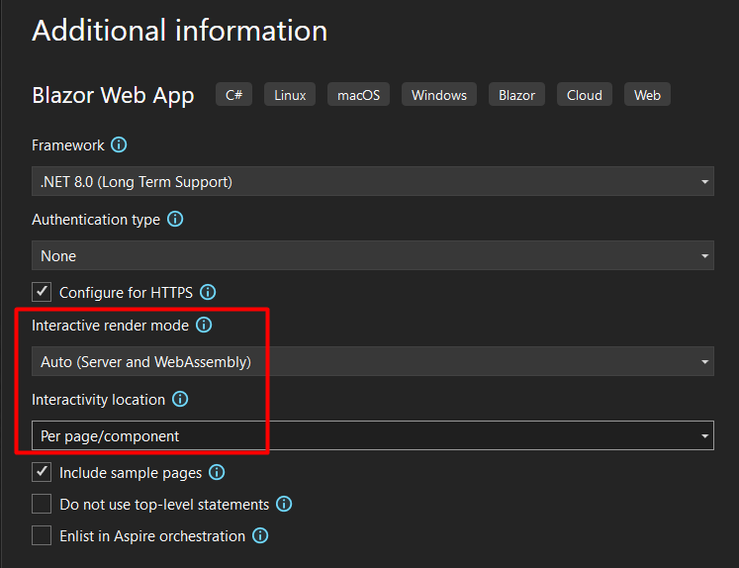

1. What Are Render Modes in Blazor Web App?
A render mode defines where a Blazor component is rendered and where its logic executes.
In a Blazor Web App, each component can independently choose:
- Where it runs
- How it becomes interactive
- When WebAssembly is downloaded
This is the major architectural change introduced in .NET 8.

2. Why Render Modes Were Introduced
Before .NET 8:
- You had to choose Blazor Server or Blazor WebAssembly at project creation time.
With .NET 8+:
- A single project can mix Server + WebAssembly
- Interactivity can be progressive
- Performance, scalability, and UX can be optimized per component

3. The Four Render Modes
1. Static (Default)
- Server-side rendering only
- No interactivity
- No SignalR
- No WebAssembly
<h3>Hello World</h3>
Use cases:
- Landing pages
- SEO-focused content
- Read-only pages

2. InteractiveServer
- Component executes on the server
- UI updates via SignalR
- Thin client
@rendermode InteractiveServer
Characteristics:
- Real-time UI updates
- Low client CPU usage
- Requires persistent connection
Best for:
- Dashboards
- Admin portals
- Intranet applications

3. InteractiveWebAssembly
- Component executes in the browser
- Downloads .NET runtime + app DLLs
- No server connection after load
@rendermode InteractiveWebAssembly
Characteristics:
- Client-side execution
- Offline capability
- Higher initial load time
Best for:
- Public-facing apps
- Offline-first applications
- High-scale systems

4. InteractiveAuto
- Starts as Server
- Seamlessly switches to WebAssembly
@rendermode InteractiveAuto
Characteristics:
- Fast initial render
- Becomes client-side after load
This is the recommended default for most apps.

4. Render Mode Comparison Table
Feature | Static | Server | WebAssembly | Auto
Interactive | ❌ | ✅ | ✅ | ✅
SignalR | ❌ | ✅ | ❌ | Initial only
Offline | ❌ | ❌ | ✅ | ✅ (after WASM)
SEO | ✅ | ✅ | ⚠️ | ✅
Initial Load | Fast | Fast | Slow | Fast
Scalability | High | Limited | Very High | High

5. Where Render Modes Are Applied
Component-Level (Recommended)
@rendermode InteractiveAuto
Page-Level
@page "/products"
@rendermode InteractiveWebAssembly
App-Level (Not Recommended)
Applied globally — reduces flexibility.

6. Program.cs Configuration (Mandatory)
To enable render modes:
builder.Services.AddRazorComponents()
.AddInteractiveServerComponents()
.AddInteractiveWebAssemblyComponents();
Without this, interactive modes will not work.

